Integrate Zscaler with Identity Providers (IdPs) such as Azure AD, Okta, and Active Directory for seamless authentication and authorization.

GROUP DETAILS:

NAME:
Team ID: SWTID-2026-8931
Team Leader: JANANI S
Team Member: KEERTHIKA A
Team Member: SUDARMANI J
Team Member: ROSHAN IRFAN M

COLLEGE NAME: Pollachi College of Arts and Science, Poosaripatti

CONTACT:
Team Leader: JANANI S
Email Id: 23nmcsjanani@gmail.com
Team Member: KEERTHIKA A
Email Id: 23nmcskeerthika@gmail.com
Team Member: SUDARMANI J
Email Id: 23nmcssudarmani@gmail.com
Team Member: ROSHAN IRFAN M
Email Id: 23nmcsroshanirfan@gmail.com

PROJECT DETAILS:

TITLE: Integrate Zscaler with Identity Providers (IdPs) such as Azure AD, Okta, and Active Directory for seamless authentication and authorization.

INTRO:
In today’s digital environment, organizations use many cloud applications and online services. To protect these systems and ensure secure access, strong authentication and authorization mechanisms are required. Zscaler is a cloud-based security platform that helps organizations securely connect users to applications from anywhere. By integrating Zscaler with Identity Providers such as Microsoft Azure Active Directory, Okta, and Active Directory, organizations can manage user authentication and authorization in a centralized and secure manner.
This integration enables Single Sign-On (SSO), which allows users to access multiple applications using one set of login credentials. It improves security by verifying user identity before granting access and reduces the risk of unauthorized access. Additionally, it simplifies user management for administrators by allowing them to control permissions, policies, and user access from a single identity platform.
The main objective of this project is to demonstrate how Zscaler can be integrated with different Identity Providers to provide seamless, secure, and efficient authentication and authorization for users accessing organizational resources. This helps enhance security, improve user experience, and streamline identity management within modern IT infrastructures.

ABSTRACT:
This project focuses on integrating Zscaler with Identity Providers (IdPs) such as Azure AD, Okta, and Active Directory to provide secure and seamless authentication and authorization for users. The main objective is to ensure that users can safely access organizational resources through a centralized identity management system.
By integrating Zscaler with these IdPs, user authentication can be performed using secure protocols like SAML or Single Sign-On (SSO). This allows employees to log in once and securely access multiple applications without repeatedly entering credentials. It also improves security by verifying user identity before granting access to network resources.
The system helps organizations manage user identities, enforce security policies, and protect sensitive data from unauthorized access. Overall, this integration enhances network security, simplifies user access management, and improves productivity by providing a reliable and secure authentication framework.

USE CASE SCENARIO:

Use Case Scenario 1 : Remote Employee Secure Access
In many organizations, employees work from different locations such as home, office, or while travelling. When an employee tries to access company applications through the internet, the request is first processed by Zscaler. Zscaler then redirects the user to an Identity Provider like Microsoft Azure Active Directory for authentication. The employee enters their credentials, and the Identity Provider verifies their identity. Once the authentication is successful, Zscaler allows secure access to the required application without exposing the internal company network to the public internet. This ensures employees can work from anywhere while maintaining strong security.

Use Case Scenario 2: Single Sign-On (SSO) for Multiple Applications
Organizations often use multiple cloud applications such as email services, project management tools, and internal portals. Remembering separate login credentials for each application can be difficult for employees. By integrating Zscaler with Identity Providers such as Okta, users can benefit from Single Sign-On (SSO). In this scenario, the employee logs in once using their Identity Provider account. After successful authentication, the same session can be used to access multiple applications connected through Zscaler without logging in again. This improves user convenience, increases productivity, and reduces password-related security risks.

Use Case Scenario 3: Secure Access to Internal Applications
Many companies have internal web portals, databases, or applications that should only be accessed by authorized employees. When a user tries to open an internal resource, Zscaler verifies the user’s identity through the organization’s Identity Provider such as Active Directory. If the user credentials are valid and the user has permission to access that application, Zscaler establishes a secure connection between the user and the application. If the user is not authorized, access will be denied. This helps organizations protect sensitive business information and prevent unauthorized users from accessing critical systems.

Use Case Scenario 4: Role-Based Access Control (RBAC)
In an organization, different employees have different responsibilities and levels of access. For example, managers may have access to financial reports, while regular employees may only access general applications. Through Identity Providers like Azure AD or Okta, administrators can assign roles and permissions to users. When a user logs in, Zscaler checks the user’s role information from the Identity Provider and allows access only to the applications permitted for that role. This ensures that employees can only access resources relevant to their job responsibilities, reducing the risk of data misuse or accidental data exposure.

Use Case Scenario 5: Protection Against Unauthorized Access and Security Threats
Cyber attackers often attempt to gain unauthorized access to company systems by stealing user credentials or exploiting weak authentication systems. With Zscaler integrated with Identity Providers, every access request must go through a strong authentication process. If an unknown user or attacker attempts to log in with invalid credentials, the Identity Provider will fail the authentication process. Zscaler will then block the connection and prevent the attacker from accessing the organization’s resources. This layered security approach helps organizations protect sensitive data, maintain compliance, and reduce the risk of cyber attacks.

STAGE 1

TITLE : Owasp to 10

Overview:
In this stage, the project begins with understanding the OWASP Top 10, which is a list of the most critical web application security risks. OWASP is a globally recognized organization that provides guidelines to improve software security.
The OWASP Top 10 includes common vulnerabilities such as Broken Access Control, Cryptographic Failures, Injection, Security Misconfiguration, and Identification & Authentication Failures. These vulnerabilities can allow attackers to access sensitive data, bypass authentication, or damage the system.
In this project, studying the OWASP Top 10 helps identify potential security threats in authentication and authorization systems. By understanding these risks, appropriate security measures can be implemented while integrating Zscaler with Identity Providers like Azure AD, Okta, and Active Directory.
This stage mainly focuses on learning about common security vulnerabilities and understanding how they impact web applications and user authentication systems. This knowledge helps in designing a more secure integration in the next stages.

S.no | Vulnerability Name | CWE/CVE no
1 | Absolute path traversal | CWE 36
2 | Sensitive cookie in HTTPS Session without ‘Secure’  Attribute | CWE – 614
3 | Use of Unmaintained Third  Party components | CWE- 1104

Report:
1.Vulnerability Name: Absolute Path Traversal
Cwe/cve number: CWE 36
Owasp category: A01:2025 Broken Access Control
Description: Absolute path Travels allows attackers to access restricted files or directions by manipulating file path due to improper inputnvalidation.
Business impact: Attackers may gain unaunthrized access to sensitive files, leading to data leakage and security risks.
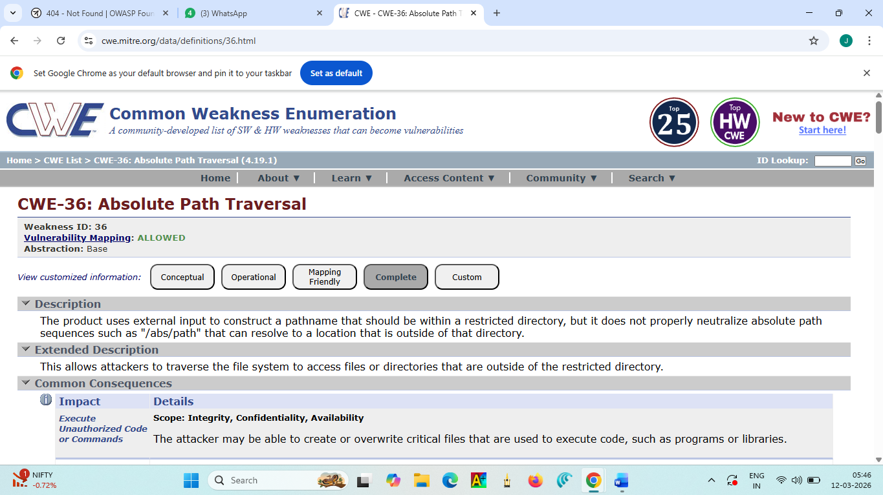
Report:
2.Vulnerability Name: Sensitive cookie in HTTPS Session without ‘Secure’ Attribute
Cwe/cve number: CWE – 614
Owasp category: A02:2025 Security Misconfiguration
Description: This Vulnerability occurs when a web application does not properly validate file paths. Attackers can manipulate the path to access files outside the allowed directory.
Business impact: Attackers may access sensitive files , modify system data, and cause data leakage or system compromise.
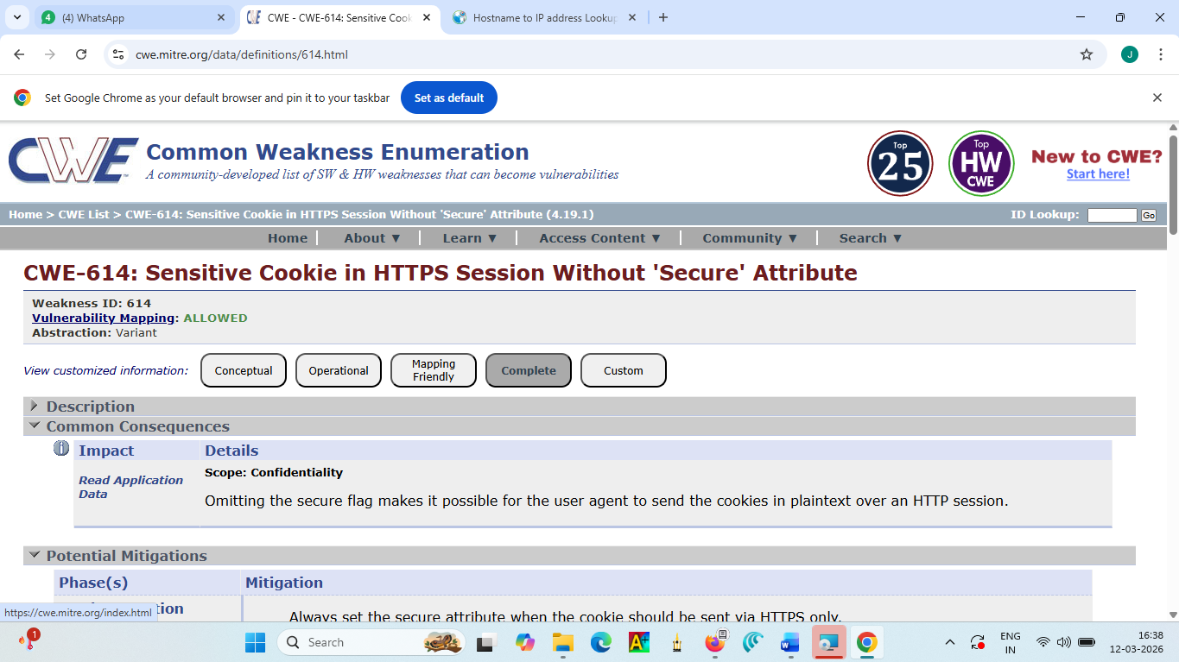
Report:
3.Vulnerability Name: Use of Unmaintained Third Party components
Cwe/cve number: CWE- 1104
Owasp category: A03:2025 Software Supply Chain Failures
Description: This Vulnerability occurs when a software application uses third-party components or libraries that are no longer maintained or updated. These components may contain known security vulnerabilities that attackers can exploit.
Business impact: Attackers may exploit these vulnerabilities to access sensitive data, compromise the system, or cause security breaches, leading to financial loss and reputational damage for the organization.
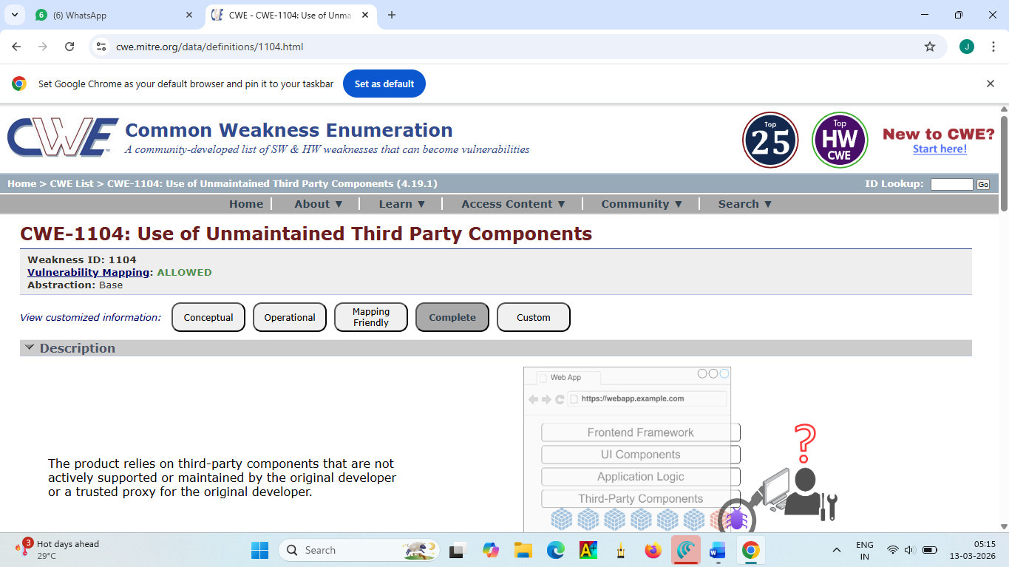

STAGE-2:
Title: Nessus scan
Overview:
In this stage, vulnerability assessment is performed using Nessus, which is one of the most widely used tools for identifying security weaknesses in systems and networks. The main purpose of this stage is to detect vulnerabilities that could potentially be exploited by attackers and ensure that the system is secure before further implementation.
Nessus works by scanning the target system or network and analyzing different components such as operating systems, applications, services, and network configurations. It checks for known vulnerabilities, outdated software versions, missing patches, weak security configurations, and exposed services. The tool compares the scanned system with an updated vulnerability database to detect possible security risks.
During the scanning process, Nessus performs different types of checks including port scanning, configuration analysis, malware detection, and compliance checks. These checks help in identifying open ports, insecure protocols, weak encryption methods, and other potential threats that may affect the security of the system. By performing these tests, the tool provides a complete overview of the system’s security posture.
Once the scan is completed, Nessus generates a comprehensive vulnerability report. This report includes detailed information about each detected vulnerability along with its description, severity level, and possible impact on the system. The vulnerabilities are categorized based on severity levels such as Low, Medium, High, and Critical, which helps security teams prioritize which issues need to be fixed first.
The report also provides recommended solutions and remediation steps to fix the vulnerabilities. These recommendations may include updating software, applying security patches, changing configurations, disabling unnecessary services, or strengthening access control mechanisms. By following these suggestions, organizations can reduce the chances of security breaches and improve overall system protection.
In this project, Nessus vulnerability scanning plays an important role in identifying and analyzing potential security risks before integrating the system with Identity Providers and Zscaler. Detecting vulnerabilities at an early stage helps ensure that the system environment is secure, stable, and ready for secure authentication and authorization processes.
Overall, this stage helps in improving the security, reliability, and protection of the system by proactively identifying and addressing vulnerabilities before they can be exploited.

S.no | Vulnerability name | Severity | Pulgins
1 | TLS Version 1.0 Protocol Detection | Medium | 104743
2 | JQuery 1.2 < 3.5.0 Multiple XSS | Medium | 136929
3 | SSL/TLS Diffie-Hellman Modulus <= 1024 Bits (Logjam) | Low | 83875
4 | Nessus SYN scanner | Info | 11219
5 | Common Platform Enumeration (CPE) | Info | 45590
6 | Patch Report | Info | 66334
7 | Additional DNS Hostnames | Info | 46180
8 | Device Type | Info | 54615
9 | Nessus Scan Information | Info | 19506
10 | OS Fingerprints Detected | Info | 209654
List of Vulnerability:

REPORT:
1)Vulnerability Name: - TLS Version 1.0 Protocol Detection
Severity : Medium
Plugin: 104743
Port: 443
Description: The remote service accepts connections encrypted using TLS 1.0. TLS 1.0 has a number of cryptographic design flaws. Modern implementations of TLS 1.0 mitigate these problems, but newer versions of TLS like 1.2 and 1.3 are designed against these flaws and should be used whenever possible.
As of March 31, 2020, Endpoints that aren’t enabled for TLS 1.2 and higher will no longer function properly with major web browsers and major vendors.
PCI DSS v3.2 requires that TLS 1.0 be disabled entirely by June 30, 2018, except for POS POI terminals (and the SSL/TLS termination points to which they connect) that can be verified as not being susceptible to any known exploits.
Solution: Enable support for TLS 1.2 and 1.3, and disable support for TLS 1.0.
Business Impact: Using outdated TLS 1.0 protocol can expose sensitive business data to attackers. This may lead to data breaches, loss of customer trust, and non-compliance with security standards, which can affect the organization’s reputation and operations.

2) Vulnerability Name: - JQuery 1.2 < 3.5.0 Multiple XSS

Severity : Medium
Plugin: 136929
Port: 80
Description: According to the self-reported version in the script, the version of JQuery hosted on the remote web server is greater than or equal to 1.2 and prior to 3.5.0. It is, therefore, affected by multiple cross site scripting vulnerabilities.
Note, the vulnerabilities referenced in this plugin have no security impact on PAN-OS, and/or the scenarios required for successful exploitation do not exist on devices running a PAN-OS release.
Solution: Upgrade to JQuery version 3.5.0 or later.
Business Impact: This vulnerability may allow attackers to inject malicious scripts into web applications. It can lead to session hijacking, unauthorized access to user data, and compromise of business applications, affecting service reliability and user trust.

3) Vulnerability Name: - SSL/TLS Diffie-Hellman Modulus <= 1024 Bits (Logjam)

Severity : Low
Plugin: 83875
Port: 443
Description: The remote host allows SSL/TLS connections with one or more Diffie-Hellman moduli less than or equal to 1024 bits. Through cryptanalysis, a third party may be able to find the shared secret in a short amount of time (depending on modulus size and attacker resources). This may allow an attacker to recover the plaintext or potentially violate the integrity of connections.
Solution: Reconfigure the service to use a unique Diffie-Hellman moduli of 2048 bits or greater.
Business Impact: Weak encryption keys can allow attackers to intercept and decrypt sensitive communication. This can expose confidential business information and internal communications, leading to potential data leakage.

4) Vulnerability Name: - Nessus SYN scanner

Severity : Info
Plugin: 11219
Port: 80
Description: This plugin is a SYN 'half-open' port scanner. It shall be reasonably quick even against a firewalled target.
Note that SYN scans are less intrusive than TCP (full connect) scans against broken services, but they might cause problems for less robust firewalls and also leave unclosed connections on the remote target, if the network is loaded.
Solution: Protect your target with an IP filter.
Business Impact: This indicates that the system ports can be detected through scanning. Attackers may use this information to identify open ports and plan targeted attacks, which could increase security risks if not properly controlled.

5) Vulnerability Name: - Common Platform Enumeration (CPE)

Severity : Info
Plugin: 45590
Port: N/A
Description: By using information obtained from a Nessus scan, this plugin reports CPE (Common Platform Enumeration) matches for various hardware and software products found on a host.
Note that if an official CPE is not available for the product, this plugin computes the best possible CPE based on the information available from the scan.
Solution: N/A
Business Impact: CPE information reveals details about the platform and software versions used in the system. Attackers may use this information to identify known vulnerabilities and exploit them, potentially affecting system security.

6) Vulnerability Name: - Patch Report

Severity : Info
Plugin: 66334
Port: N/A
Description: The remote host is missing one or more security patches. This plugin lists the newest version of each patch to install to make sure the remote host is up-to-date.
Note: Because the 'Show missing patches that have been superseded' setting in your scan policy depends on this plugin, it will always run and cannot be disabled.
Solution: Install the patches listed below.
Business Impact: Missing or outdated security patches can leave the system vulnerable to known threats. This can result in system compromise, malware infections, and operational disruptions, impacting business continuity.

7) Vulnerability Name: - Additional DNS Hostnames

Severity : Info
Plugin: 46180
Port: N/A
Description: Hostnames different from the current hostname have been collected by miscellaneous plugins. Nessus has generated a list of hostnames that point to the remote host. Note that these are only the alternate hostnames for vhosts discovered on a web server.
Different web servers may be hosted on name-based virtual hosts.
Solution: If you want to test them, re-scan using the special vhost syntax, such as :
www.example.com[192.0.32.10]
Business Impact: Exposure of additional DNS hostnames may reveal internal system information. Attackers can use this data to map the network structure and identify potential attack targets within the organization.

8) Vulnerability Name: - Device Type

Severity : Info
Plugin: 54615
Port: N/A
Description: Based on the remote operating system, it is possible to determine what the remote system type is (eg: a printer, router, general-purpose computer, etc).
Solution: N/A
Business Impact: Identifying the device type may help attackers understand the system environment. This knowledge can assist them in planning targeted attacks on specific devices or systems.

9) Vulnerability Name: - Nessus Scan Information

Severity : Info
Plugin: 19506
Port: N/A
Description: This plugin displays, for each tested host, information about the scan itself:
- The version of the plugin set.
- The type of scanner (Nessus or Nessus Home).
- The version of the Nessus Engine.
- The port scanner(s) used.
- The port range scanned.
- The ping round trip time
- Whether credentialed or third-party patch management checks are possible.
- Whether the display of superseded patches is enabled
- The date of the scan.
- The duration of the scan.
- The number of hosts scanned in parallel.
- The number of checks done in parallel.
Solution: N/A
Business Impact: This provides details about the scanning process and system information. While informational, it may reveal system configuration details that attackers could analyze for potential weaknesses.

10) Vulnerability Name: OS Fingerprints Detected

Severity : Info
Plugin: 209654
Port: N/A
Description: Using a combination of remote probes (TCP/IP, SMB, HTTP, NTP, SNMP, etc), it was possible to gather one or more fingerprints from the remote system. While the highest-confidence result was reported in plugin 11936, “OS Identification”, the complete set of fingerprints detected are reported here.
Solution: N/A
Business Impact: Detection of the operating system can help attackers identify OS-specific vulnerabilities. If exploited, it could lead to system compromise, unauthorized access, or service disruption.

STAGE 3:
Title: Integrate Zscaler with Identity Providers (IdPs) such as Azure AD, Okta, and Active Directory for seamless authentication and authorization.

Zero Trust Identity Principles:
The integration of Zscaler with Identity Providers is fundamentally rooted in Zero Trust Architecture principles that transform how authentication and authorization are handled. The core principle of "never trust, always verify" means every access request is fully authenticated and authorized regardless of whether the user is in the office or working remotely. "Least privilege access" ensures users are granted only the minimum access necessary to perform their job functions, enforced through identity-based policies rather than network location. "Assume breach" guides the design as if attackers are already present, requiring continuous verification of every session. "Micro-segmentation" isolates users and applications from one another to prevent lateral movement, achieved by connecting users to specific applications rather than the entire network.
Identity becomes the new perimeter, replacing the traditional castle-and-moat model where the internal network was considered trusted. Authentication must be explicit and contextual, incorporating user identity, device health, location, and behavior patterns. Authorization decisions are made dynamically based on real- time risk assessments rather than static rules. These principles directly inform how Zscaler integrates with IdPs to create a security model where identity is the primary control plane and access is granted application-by-application rather than network-by-network.

Azure AD Integration: SAML Configuration
Configuring SAML-based federation between Azure AD and Zscaler establishes the trust relationship for user authentication. Begin by logging into the Azure AD portal and navigating to Enterprise Applications, then select "New Application" and search for "Zscaler" in the gallery. Select the appropriate Zscaler application based on your Zscaler cloud name (Zscaler, Zscaler2, Zscaler3, etc.) and click Create. On the application overview page, select "Single sign-on" and choose "SAML" as the sign-on method. In the Basic SAML Configuration section, enter the Identifier and Reply URL provided by your Zscaler Admin Portal under Administration > Authentication > SAML Configuration. The Identifier typically follows the format https://<tenant>.zscloud.net/samlsp/metadata and the Reply URL is https://<tenant>.zscloud.net/samlsp/acs. Configure the User Attributes & Claims section to map Azure AD attributes to SAML assertions, ensuring the Name Identifier format is set to "Persistent" and the Source attribute is user.userprincipalname. Add additional claims as required by Zscaler, including givenname, surname, emailaddress, and group memberships. For group claims, select "Security groups" as the source and configure the group claim to include groups the user is a member of. Download the Federation Metadata XML file from Azure AD after saving the SAML configuration, as this will be uploaded to Zscaler to complete the trust configuration. Test the SAML configuration using the Azure AD test capability before proceeding to Zscaler-side configuration.

Azure AD Integration: SCIM Provisioning Setup
Configuring SCIM provisioning between Azure AD and Zscaler automates user lifecycle management, ensuring accounts are created, updated, and deprovisioned automatically. From the same Zscaler enterprise application in Azure AD, select "Provisioning" from the left navigation menu and click "Get Started." Set Provisioning Mode to "Automatic" and configure the Tenant URL using the SCIM endpoint provided in your Zscaler Admin Portal under Administration > Authentication > SCIM Configuration, typically https://<tenant>.zscloud.net/scim. Obtain the Secret Token from the same Zscaler SCIM configuration page and enter it in Azure AD. Click "Test Connection" to validate connectivity between Azure AD and Zscaler, resolving any errors before proceeding. Configure attribute mappings by expanding "Mappings" and selecting "Provision Azure Active Directory Users." Review and modify the default attribute mappings to ensure Azure AD attributes correctly map to Zscaler user schema, paying special attention to userPrincipalName mapping to userName, email mapping to emails[type eq "work"].value, and group memberships. Configure group provisioning by expanding group mappings and ensuring Azure AD groups are properly mapped to Zscaler groups for policy enforcement. Set the provisioning scope to "Sync only assigned users and groups" for controlled rollout, then assign pilot users and groups to the application under "Users and groups." Configure provisioning settings including notification emails for failures and the provisioning interval (typically 40 minutes). Start the initial provisioning cycle by clicking "Start provisioning" and monitor the provisioning logs for any errors. Validate that test users appear in the Zscaler Admin Portal with correct attributes and group memberships before expanding scope.

Okta Integration: OIDC Application Configuration
Configuring Okta as an identity provider for Zscaler using OpenID Connect provides modern, API-friendly authentication for Zscaler services. Log into the Okta Admin Console and navigate to Applications > Applications, then click "Create App Integration." Select "OIDC - OpenID Connect" as the sign-in method and "Web Application" as the application type. Name the application "Zscaler" and click Next. Configure the Sign-in redirect URIs with the Zscaler OIDC callback URL provided in your Zscaler Admin Portal under Administration > Authentication > OIDC Configuration, typically https://<tenant>.zscloud.net/oidc/callback. Configure Sign-out redirect URIs if desired for single logout functionality. Under Assignments, control access by assigning the application to specific user groups or individual users for pilot testing. Grant API access by navigating to the "Okta API Scopes" tab and granting the following scopes: openid, profile, email, groups, and offline_access. Navigate to the "Sign On" tab and note the Client ID and Client Secret, which will be entered in Zscaler during OIDC provider configuration. Under "General Settings," configure the application's login flow, ensuring "Initiate login URI" points to your Zscaler tenant URL. Optionally configure authentication policies to enforce MFA for Zscaler access. Download the Okta metadata or note the Okta domain URL (https://<okta-domain>.okta.com) for configuration in Zscaler. Test the OIDC configuration by accessing the application's sign-on URL and verifying successful authentication with MFA if configured. Validate that user attributes including name, email, and group memberships are properly passed in the ID token for Zscaler policy enforcement.
Conclusion
In this project, the integration of Zscaler with Identity Providers such as Microsoft Azure Active Directory, Okta, and Active Directory was studied to provide secure authentication and authorization for users accessing organizational resources.

Stage1
In Stage 1, the project focused on identifying common web security risks based on the OWASP Top 10 vulnerabilities and understanding their impact on web applications.

Stage2
In Stage 2 involved vulnerability assessment using Nessus scanning to detect security weaknesses in systems and applications. This stage helped in identifying potential threats and improving the security posture of the system.

Stage3
In Stage 3, the integration of Zscaler with Identity Providers was implemented to enable secure and seamless user authentication. By using identity-based security, device posture checks, application risk evaluation, and context-aware access, organizations can ensure that only authorized users and secure devices can access their applications and data. This approach enhances overall cybersecurity, improves user experience through Single Sign-On (SSO), and helps organizations effectively manage access control in a modern cloud-based environment. Overall, this project demonstrates how combining vulnerability assessment and identity-based security solutions can significantly strengthen the security infrastructure of an organization.
Future Scope
The future scope of this project is to enhance security and improve identity management by implementing more advanced technologies. The integration of Zscaler with Identity Providers such as Microsoft Azure Active Directory, Okta, and Active Directory can be further expanded to support advanced security features and better access control.
In the future, this system can be improved by implementing Multi-Factor Authentication (MFA) to provide an additional layer of security for user authentication. This will help prevent unauthorized access even if user credentials are compromised. The system can also be enhanced by integrating AI-based threat detection and automated security monitoring, which can identify suspicious activities and respond to threats in real time.
Another future improvement is the implementation of Zero Trust Security Architecture, where every user and device is continuously verified before accessing any resource. This approach will help organizations maintain stronger security policies and protect sensitive data from cyber threats.
Additionally, the system can be expanded to support cloud applications, mobile devices, and remote work environments, ensuring secure access from anywhere. By continuously updating security policies and integrating advanced technologies, this project can evolve into a more comprehensive and scalable security solution for modern organizations

Topics Explored: owasp top 10, scanning, vulnerability, awareness, identify
Tools explored: Zscaler,Nessus , Owasp , hackthissite

